Architecture Diagram
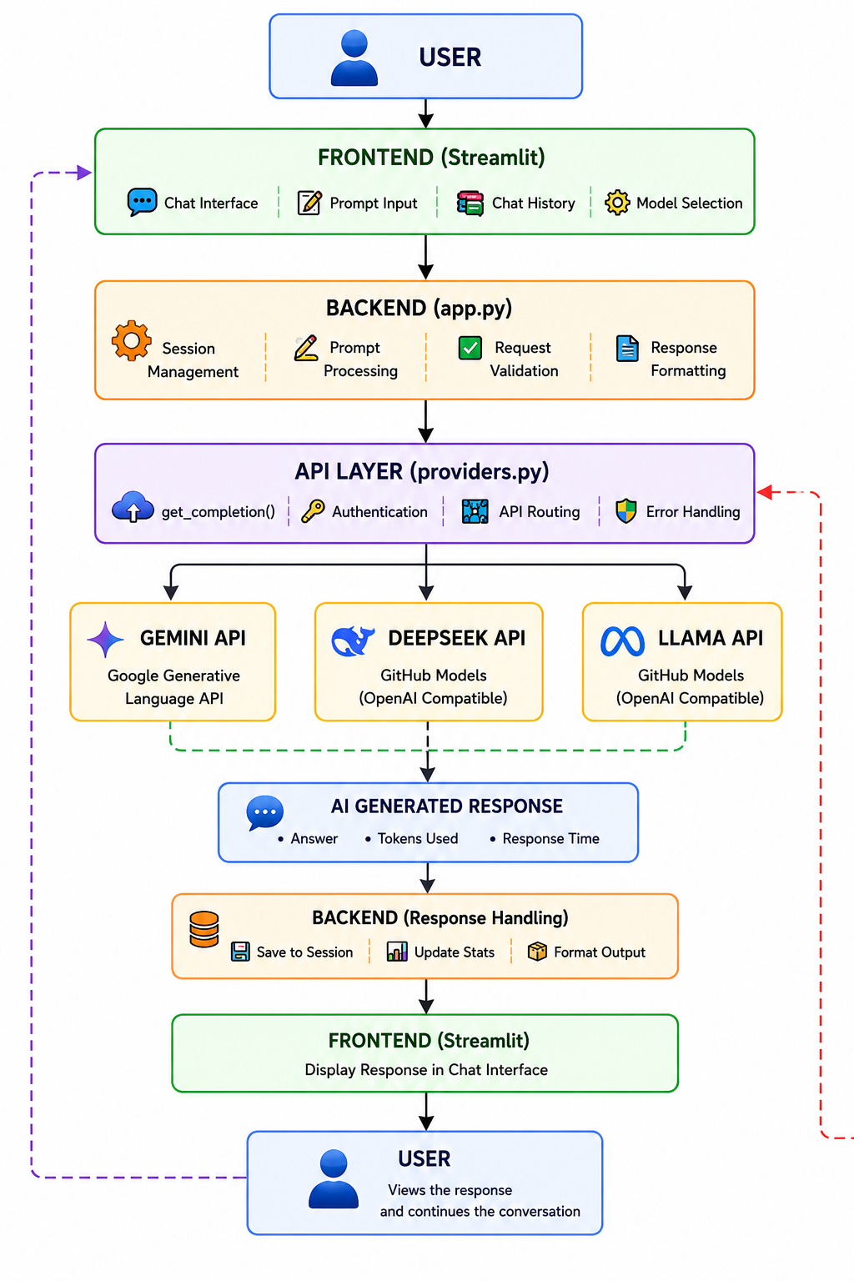
Overview
This diagram illustrates the end-to-end request-response flow of the Orbit chatbot system, from user input to AI-generated output, across a layered (3-tier) architecture: Frontend → Backend → API Layer → External LLM Providers.
1. User Layer
- USER initiates the interaction by typing a message into the chat interface.
2. Frontend Layer (Streamlit)
Handles all user-facing interactions:
- Chat Interface – renders the conversation UI
- Prompt Input – captures user queries
- Chat History – maintains conversation context
- Model Selection – allows the user to choose which LLM provider to use (Gemini, DeepSeek, or Llama)
3. Backend Layer (app.py)
Processes and manages requests before they reach the API layer:
- Session Management – tracks user sessions and state
- Prompt Processing – prepares/cleans the prompt for the model
- Request Validation – ensures input integrity before forwarding
- Response Formatting – structures the model's output for display
4. API Layer (providers.py)
The central routing and integration layer:
- get_completion() – unified function to call any provider
- Authentication – manages API keys/credentials
- API Routing – directs the request to the selected provider
- Error Handling – manages failures, timeouts, and retries (represented by the red dashed feedback arrow)
5. LLM Provider Branch (Parallel Options)
Based on user selection, one of three providers is called:
Provider | Backend Used
Gemini API | Google Generative Language API
DeepSeek API | GitHub Models (OpenAI-compatible)
Llama API | GitHub Models (OpenAI-compatible)
6. AI Generated Response
The selected provider returns:
- Answer (the actual text response)
- Tokens Used (for usage tracking)
- Response Time (for performance monitoring)
7. Backend Layer (Response Handling)
Post-processing of the AI response:
- Save to Session – stores the exchange in chat history
- Update Stats – logs token usage/performance metrics
- Format Output – prepares the final response for the frontend
8. Frontend Layer (Display)
The formatted response is rendered back into the Streamlit chat interface.
9. User Layer (Loop Closure)
- USER views the response and may continue the conversation.
- The purple dashed arrow represents this conversational feedback loop back to the Frontend, enabling multi-turn interaction.
- The red dashed arrow represents an error/retry loop back into the API Layer, used when a provider call fails.
Summary
This is a modular, provider-agnostic chatbot architecture where the API layer decouples the backend from any specific LLM vendor, allowing Orbit to support multiple model providers (Gemini, DeepSeek, Llama) interchangeably while maintaining consistent session handling, error recovery, and response formatting.

